**Case-1**

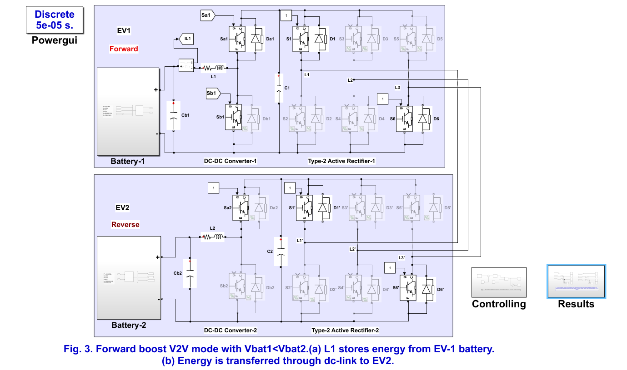

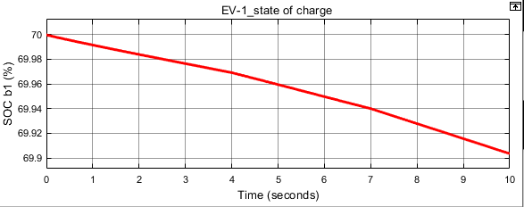

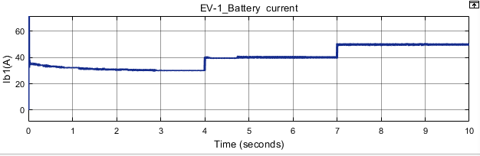

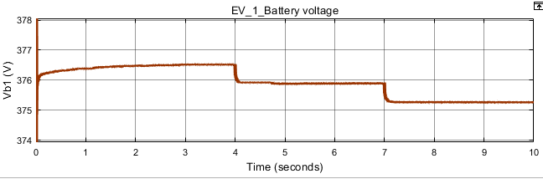

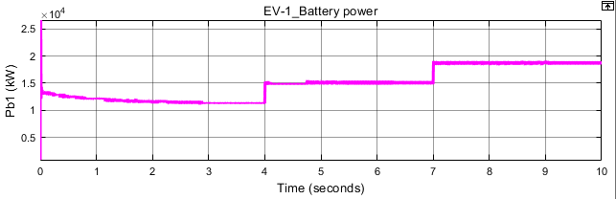

(a)

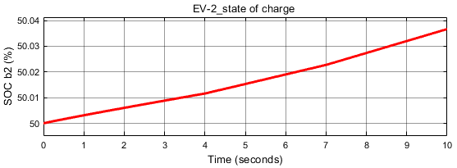

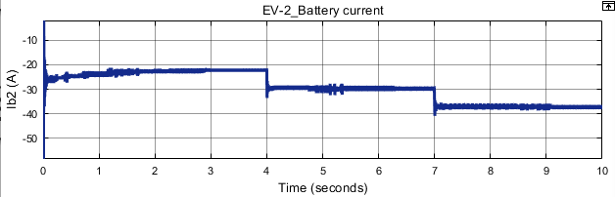

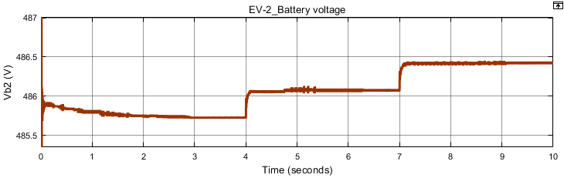

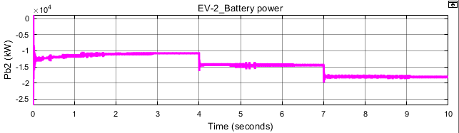

(b)

**Fig. 8. Simulation results of the proposed V2V operation in forward boost mode with Vbat1<Vbat2.(a) SOC, voltage, current, and power waveforms of EV-1 battery. (b) SOC, voltage, current, and power waveforms of EV-2 battery.**

**CASE-2**

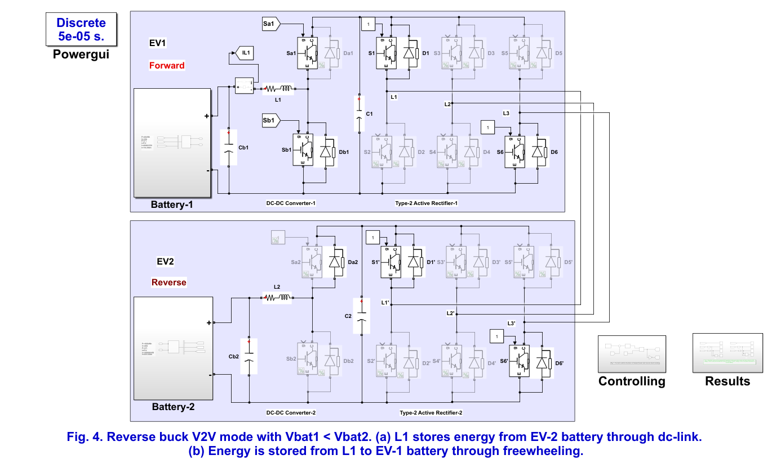

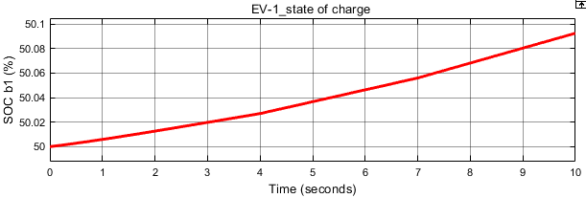

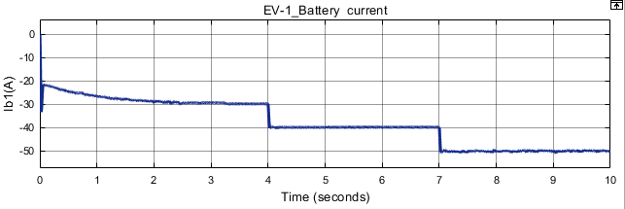

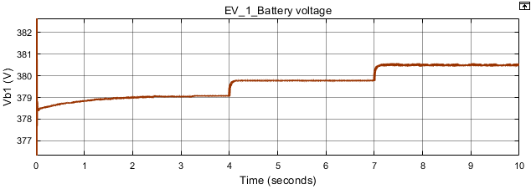

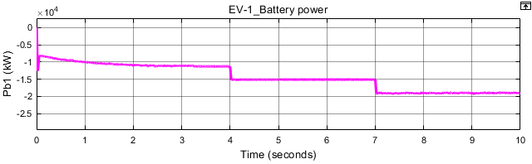

(a)

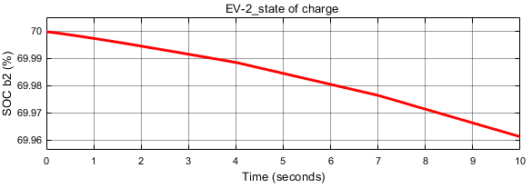

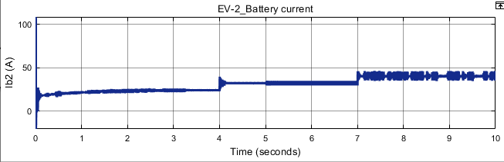

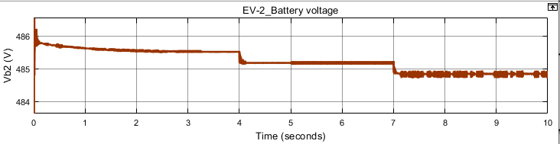

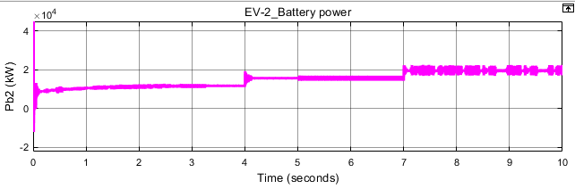

(b)

Fig. 4. Reverse buck V2V mode with Vbat1 < Vbat2. (a) L1 stores energy from EV-2 battery through dc-link. (b) Energy is stored from L1 to EV-1 battery through freewheeling.

**Case-3**

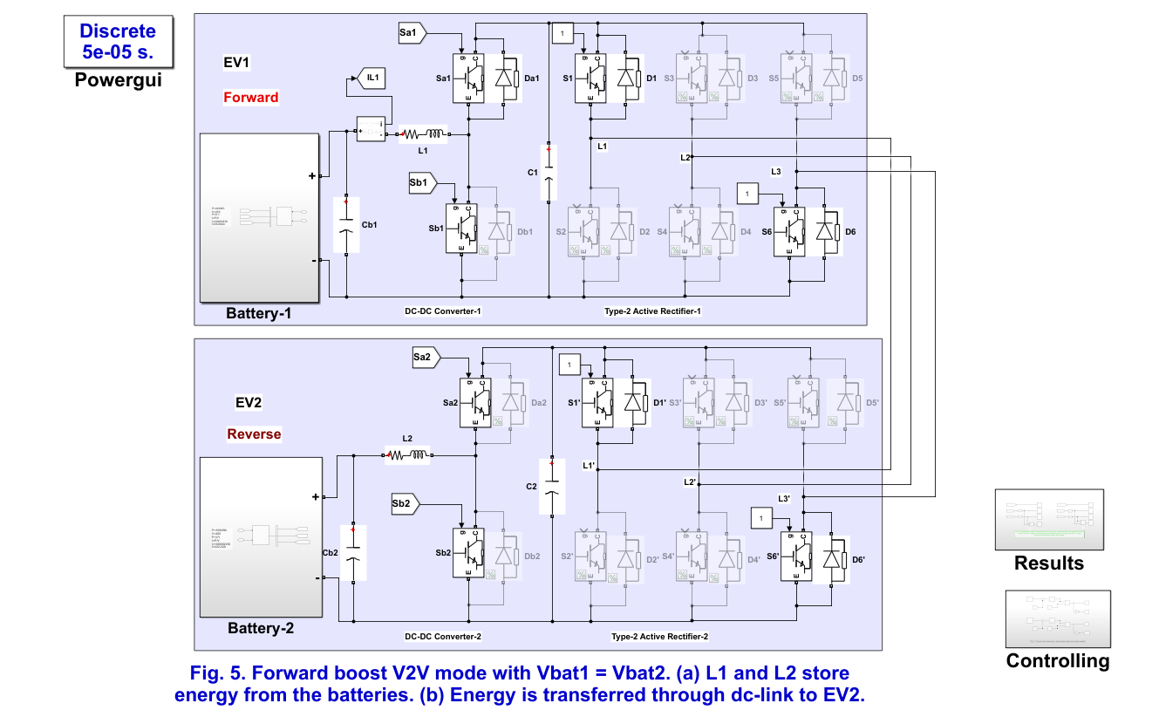

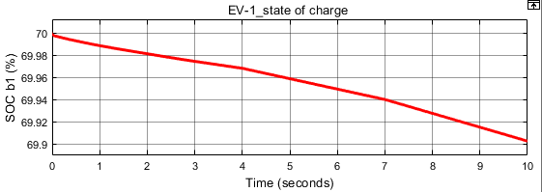

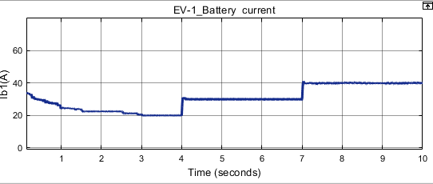

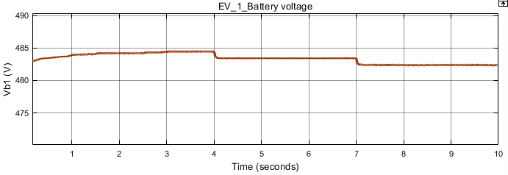

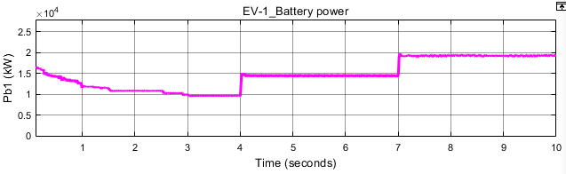

(a)

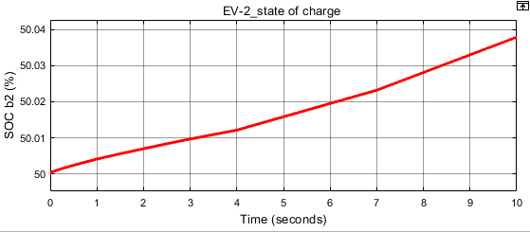

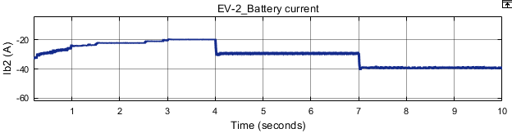

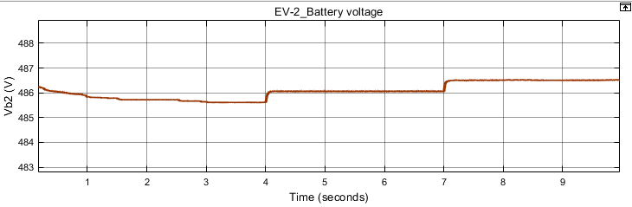

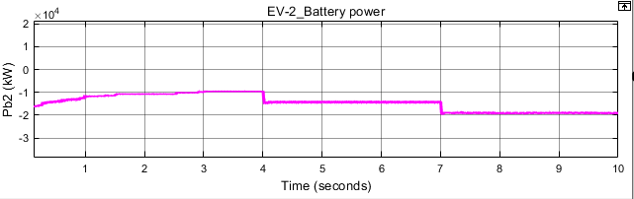

(b)

**Fig. 5. Forward boost V2V mode with Vbat1 = Vbat2. (a) L1 and L2 store energy from the batteries. (b) Energy is transferred through dc-link to EV2.**